Import Data using Transform Maps (Spreadsheet)

Abstract
In modern enterprise environments, maintaining an accurate and centralized Configuration Management Database (CMDB) or user repository is critical. However, organizations frequently receive legacy data, third-party vendor updates, and asset lists in disparate spreadsheet formats (such as XLSX or CSV). Manual entry of this data is error-prone, time-consuming, and operationally inefficient.
This project implements an automated, scalable data ingestion solution within the ServiceNow platform using Import Sets and Transform Maps. The core objective is to seamlessly import configuration item (CI) or user data from spreadsheets, staging it temporarily before mapping it to target production tables (e.g., sys_user or cmdb_ci).
The technical implementation leverages:
- Import Set Tables (Staging): To host raw, unvalidated spreadsheet data without compromising production integrity.
- Transform Maps: To establish definitive relationships between staging columns and production fields.
- Coalesce Fields: To enforce data integrity by detecting existing records, thereby handling updates (upserts) gracefully and preventing duplicates.
- Transform Scripts (OnBefore/OnAfter): To execute conditional logic, data validation, and reference field resolution during the transformation process.
The outcome of this project is a streamlined data integration pipeline that reduces manual data-entry efforts by 100%, minimizes data duplication errors, and ensures high data quality and consistency across the enterprise platform.

Description:
This micro project focuses on importing structured data from an external spreadsheet into the ServiceNow platform using Import Sets and Transform Maps. The project simulates a real-world scenario where bulk employee data is received in Excel format and must be migrated into ServiceNow efficiently and accurately. The spreadsheet data is first loaded into an Import Set table, which serves as a staging area, and a Transform Map is then configured to map source fields to the appropriate target table fields. Upon executing the transformation, records are created in the target table and validated to ensure data integrity. This project helps beginners understand the end-to-end data import process in ServiceNow, including data loading, field mapping, transformation execution, and result verification.
How Transform Maps work:

CSV / Data -> Import Set Table (Staging) -> Transform Map (Field Map & Rules) -> Target Table
- Load Data: Import data into an Import set table.
- Create Transform Map: Link Import set table to Target table.
- Map Fields: Define rule to match source columns to Target table Fields.
- Transform: Create or Update Target table.
- Verify the Target table if records are imported accurately.
Step 1: Load Data into Import Set Table
1. Navigate to All > System Import Sets > Load Data.
2. In Import set table, select create table. Give Name to the table (example: u_incidents).
3. In Source of the import. Click Choose file --> Select file (example: 'incident.csv')
4. Click on Submit Button

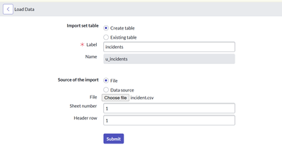

ServiceNow will create a table ‘u_incidents’ and store the csv data inside it.
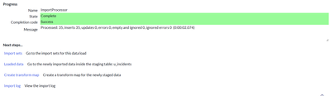

Step 2: Create a Transform Map
1. Navigate to All > System Import Sets > Create Transform Map
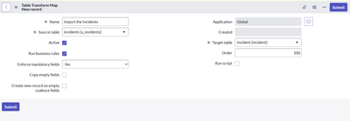

2. Click on Submit button.

Step 3: Define Field Mapping

1. Open Transform Map Record (Example: ‘Import the Incidents’)
2. Scroll down to the Related list ‘Field Map’.
3. Click on ‘New’ and create the mapping for Source Field and Target Field as follows:
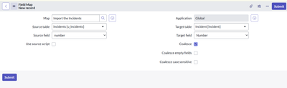

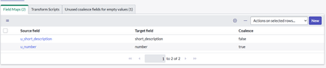

Coalesce is used to ensure that if the Import set data have the same incident number, then ServiceNow will update the existing record instead of duplicate record creation.
Step 4: Run the Transform Map
1. Go to the System Import Sets > Advanced > Import Sets
2. Open the record for your csv in Data source
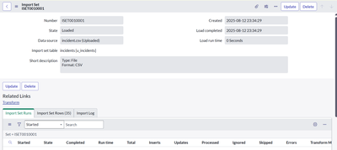

3. Within the Related links, Click Transform
4. Select ‘Import the Incidents’
Import Set Table
Navigation:
In Application Navigator → Load Data
Click on Load Data and create an import table
Fill details as shown below
- Label: Employee Import
- Name: u_employee_import (auto populated)
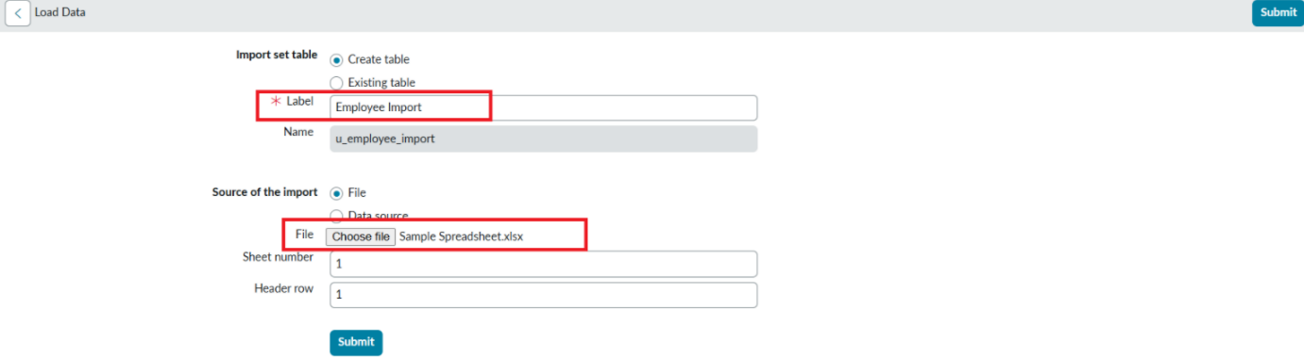

- Click on Submit
Once we click on Submit, we can see the success message as shown below.

Also we need to make sure to click on Create Transform Map.

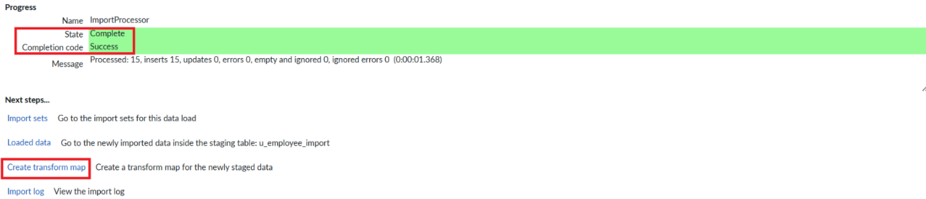

Step 4: Create Transform Map
In this phase we need to create the Transform Map by clicking on the Create Transform Map button as shown in above screenshot.

Give inputs as shown below.
Name: Sample Spreadsheet Import
Source Table: Employee Import is auto-populated
Target Table: Employee Test - as we created earlier
Click on Auto Map Matching fields.

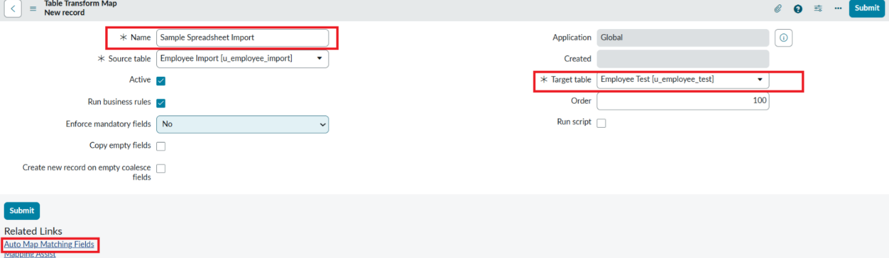

Now click on Mapping Assist and map the fields with Source & Target Table
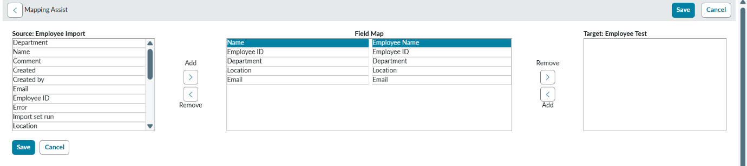
Click on Save
Make sure the both Source & Target table fields are mapped as shown below.
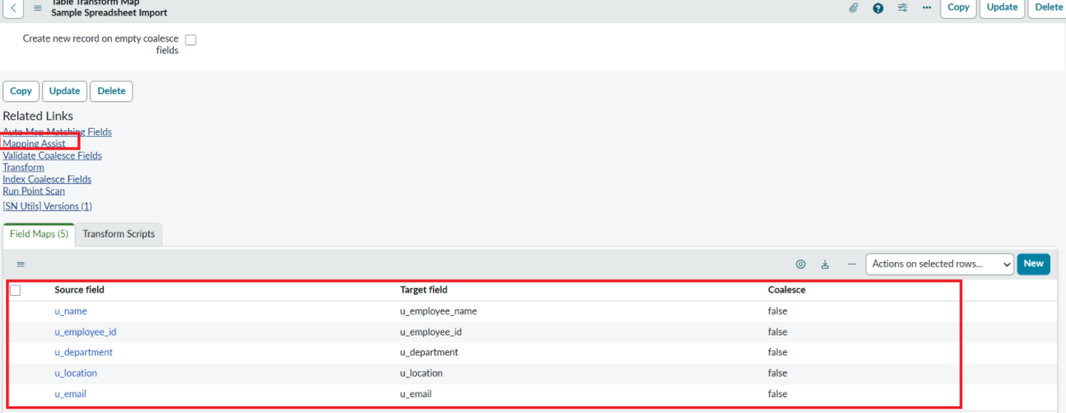

- Now click on Transform as shown below

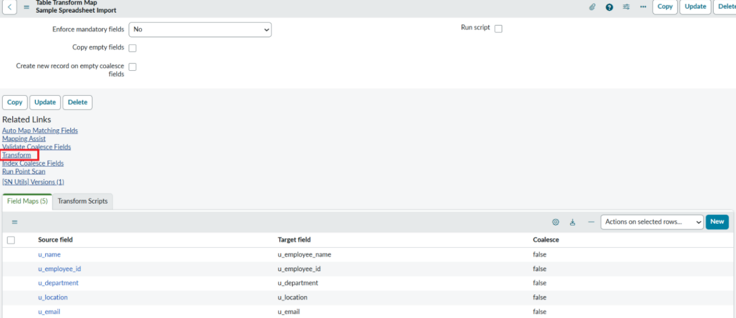

- Now click on Transform Button as shown below.

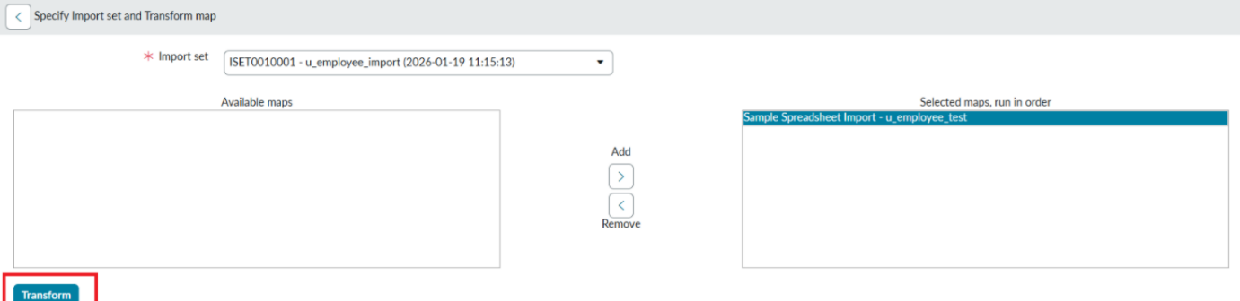

- After clicking Transform, make sure you see the success message as shown below.
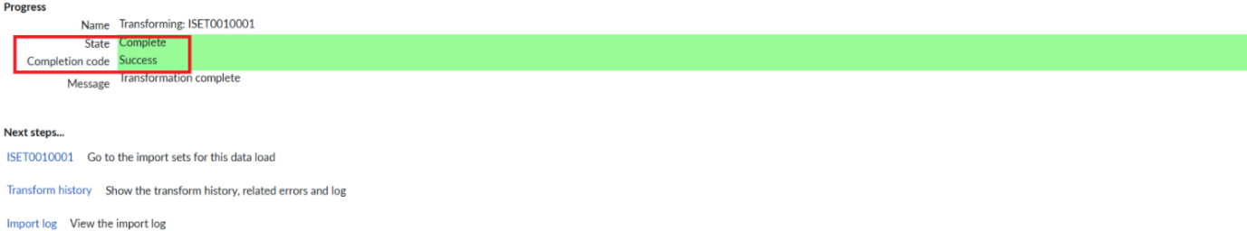
Step 5: Transform Data & Validate
Navigation:
- Open Employee Test Table from application navigator as shown below.

- As our import got succeeded, all the records are created in the Employee Test Table.

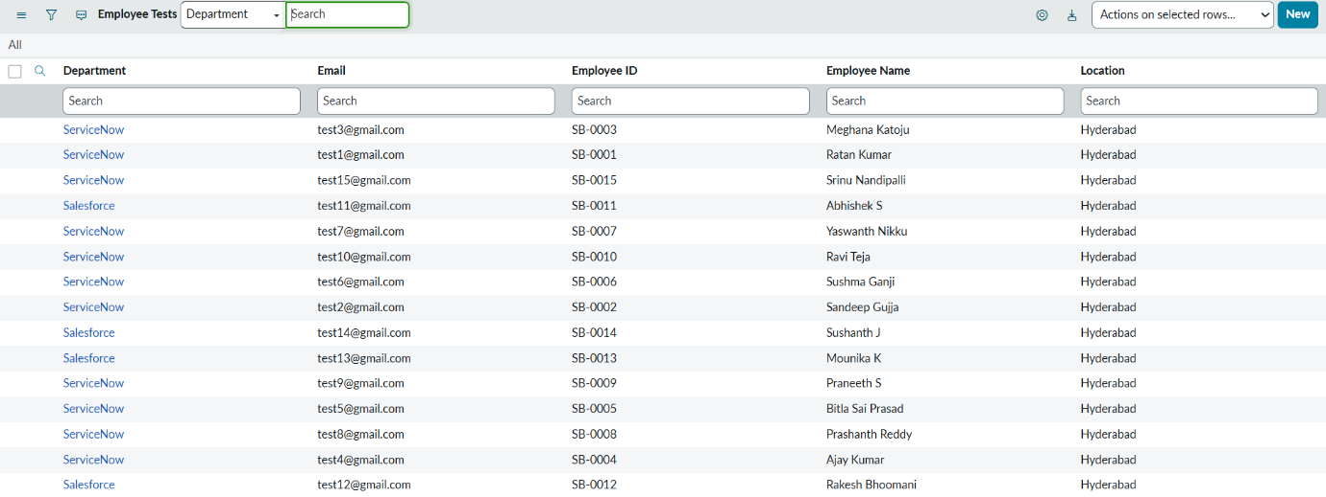
- Make sure you rearrange the fields accordingly by using Personalised List Columns
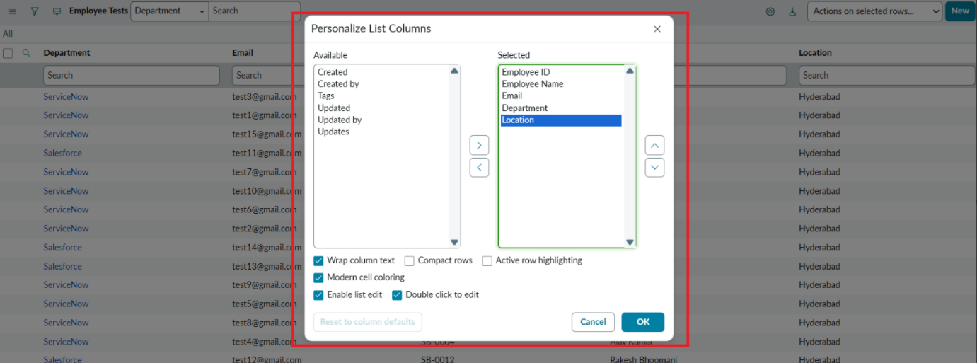

Click on OK

Final Result:
All the records are successfully imported into the ServiceNow system with Import Set, Transform Map.

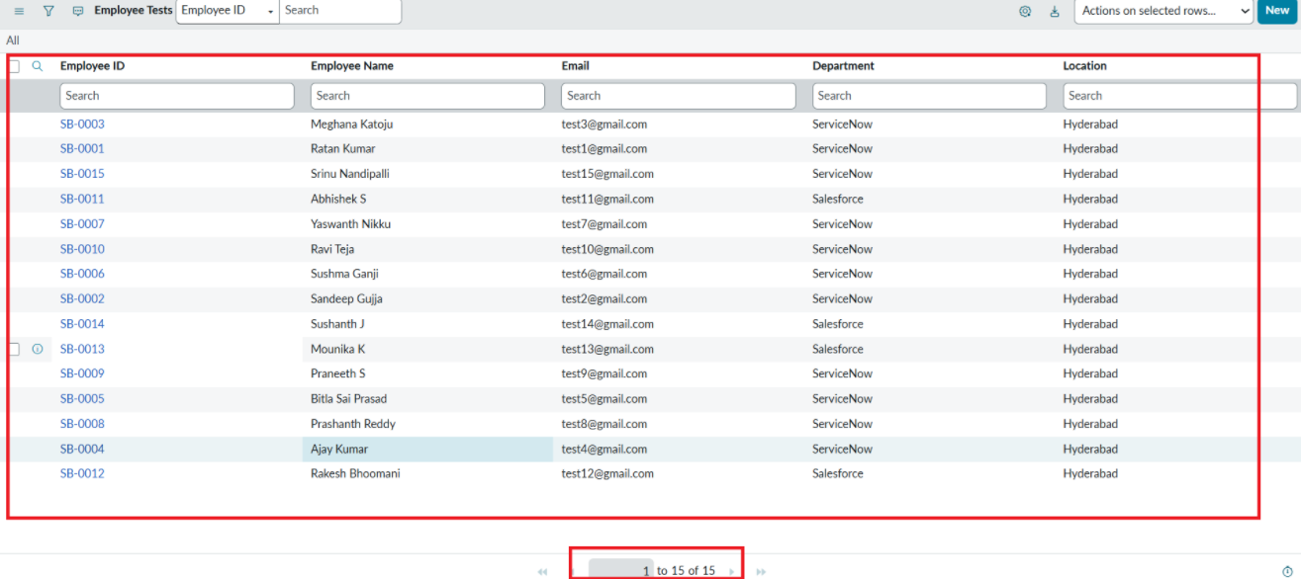
Step 6: Enable Coalesce to Avoid Duplicate Records
- In real projects, the same employee data may be imported multiple times.
- To prevent duplicate employee records, we use Coalesce.
- The Coalesce will update the same records with new values if we add and the duplicate values are not inserted.
Steps:
- Open Transform map Under System LDAP On All menus.
- Open the Created Transform map , Name is Sample Spreadsheet Import.
- Under Related list, select the Field maps Section and Make any one field Coalesce True which appears in False.
- Now save the form.
- Then again add some data which is in Excel format.
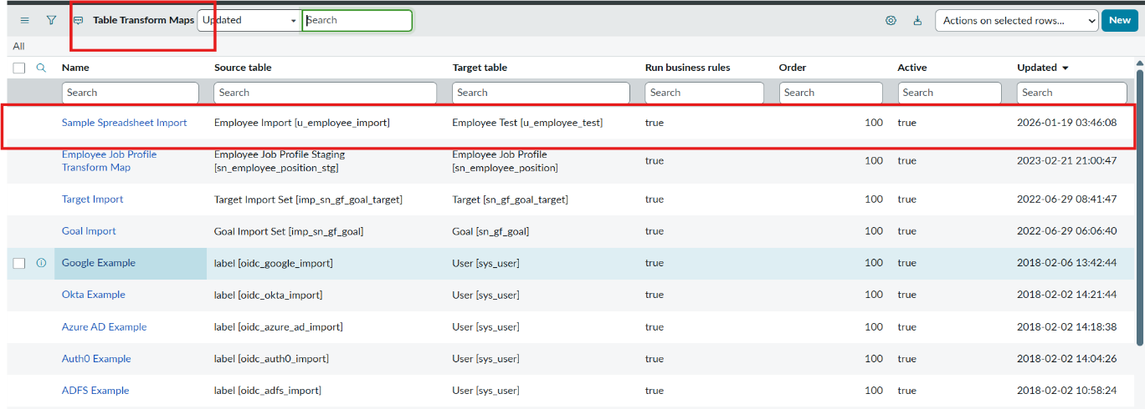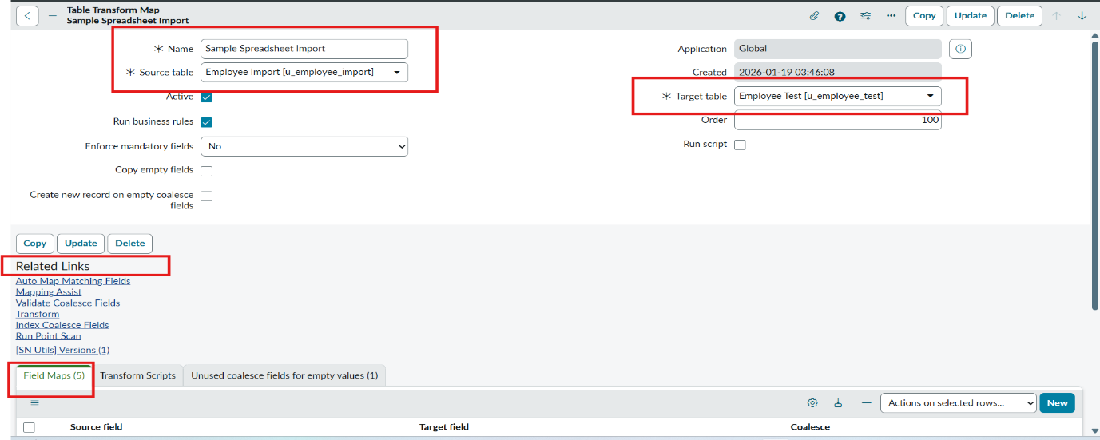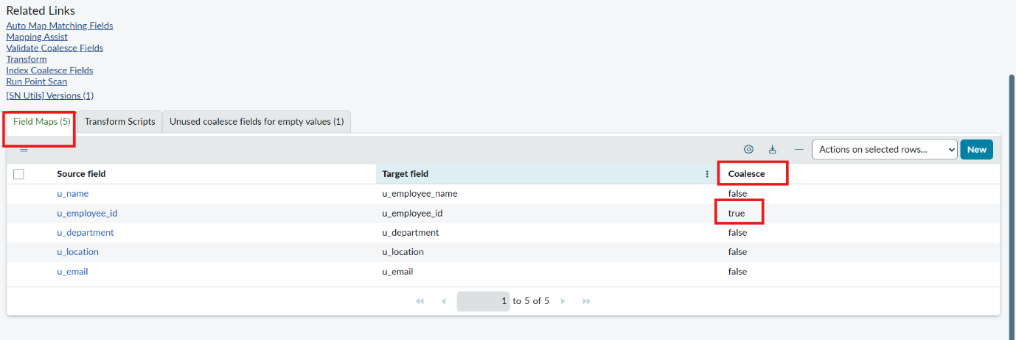

Step 7 : Inserting New Data In Excel Format
Steps :
- Navigate to All menus.
- Search for Load data Under System Import set Open Load Data.
- Fill the details as
- Import set table as select Existing table {Employee Import}.
- Source of Import is Select File and choose the file from Files.
- Sheet number : 1, Header row : 1.
- Now Click submit.
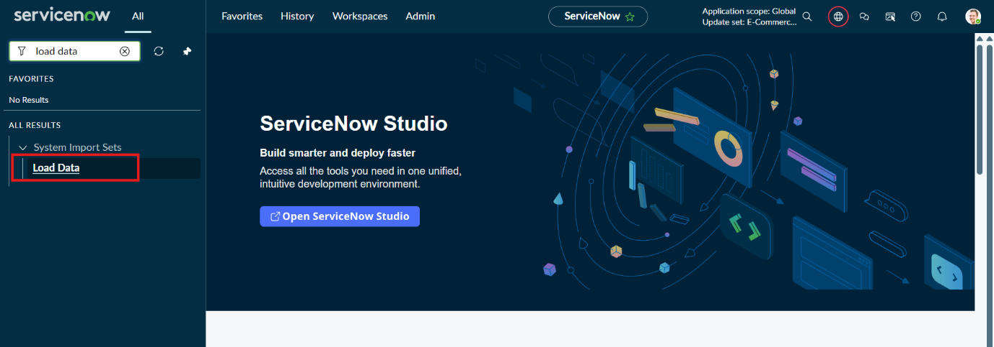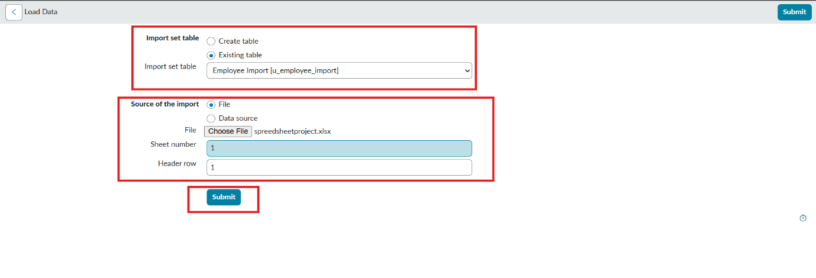

- Newly Created Excel Data is this.
- 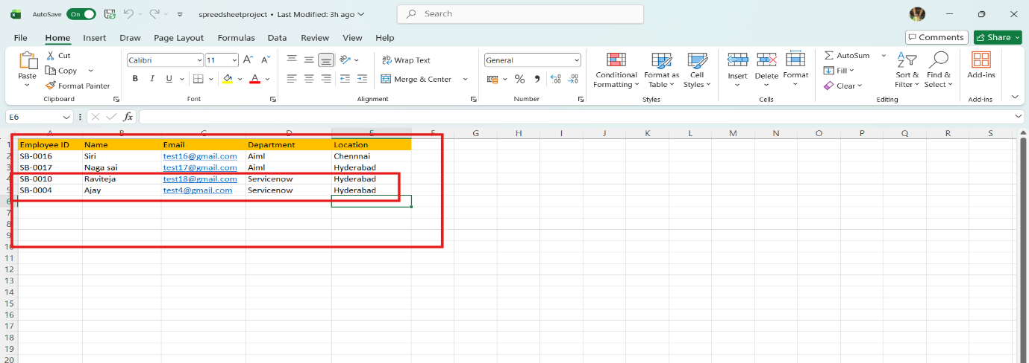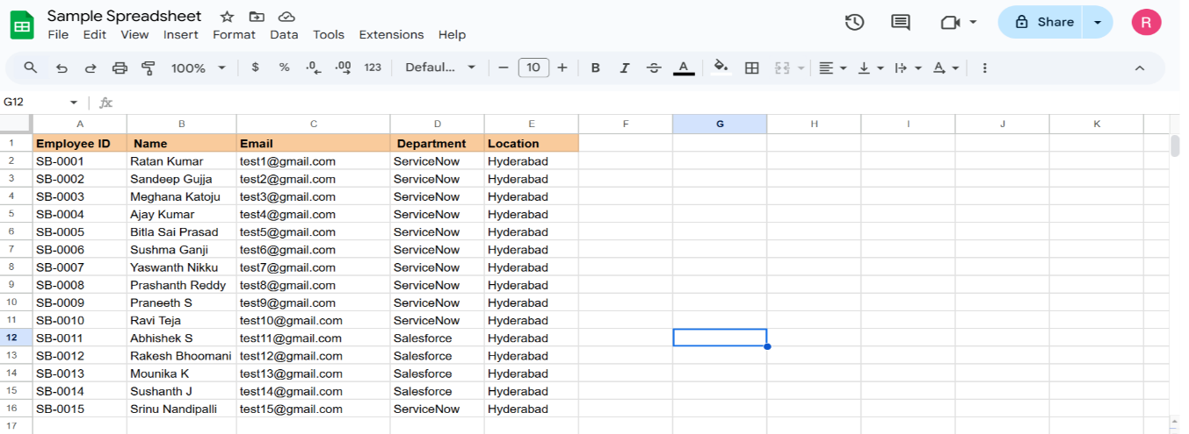It is the previously added data.
- Now, In this new data we added 4 rows of the 2 rows with the same existing data with different Name changed and Email changed.
- That Raviteja Employee Email was Changed to
[test10@gmail.com → test18@gmail.com ].
- And Employee ID with SB-OOO4 name was changed to
[Ajay kumar → Ajay].
- And two other new Employee ID’s are added.
- Now after submitting the form it appears as State Completed and Success.
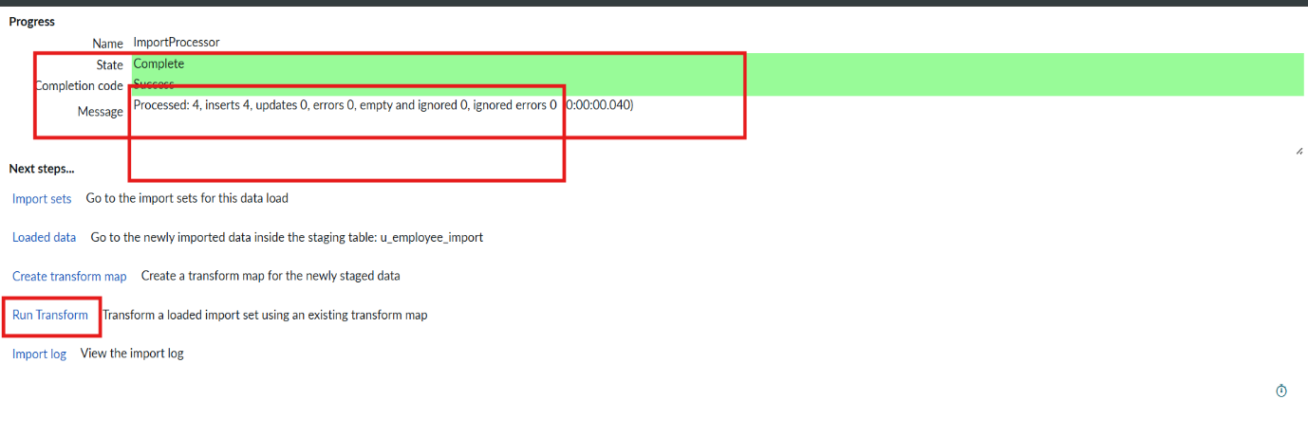
- Now Click the Run transform Under the next steps.
- Then it opens Specify Import set and transform map which is previously selected transform map then Click Transform button.
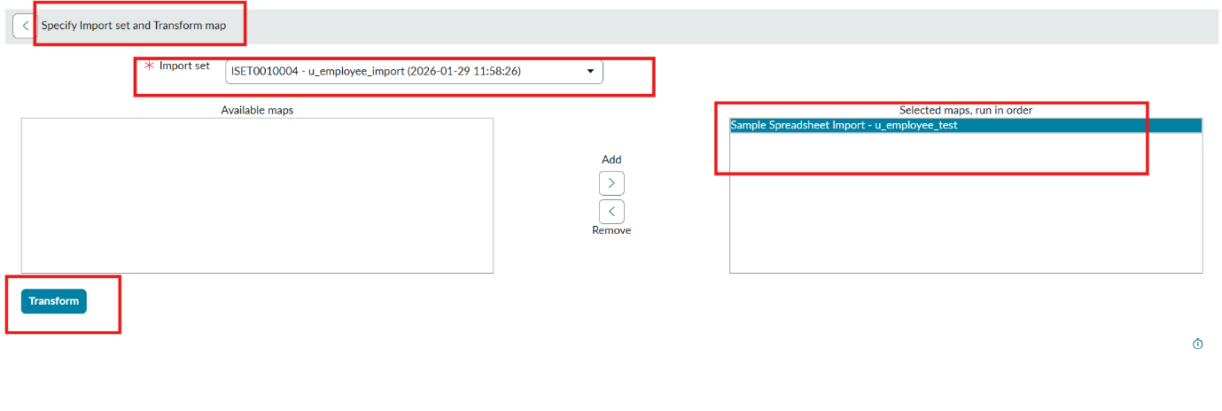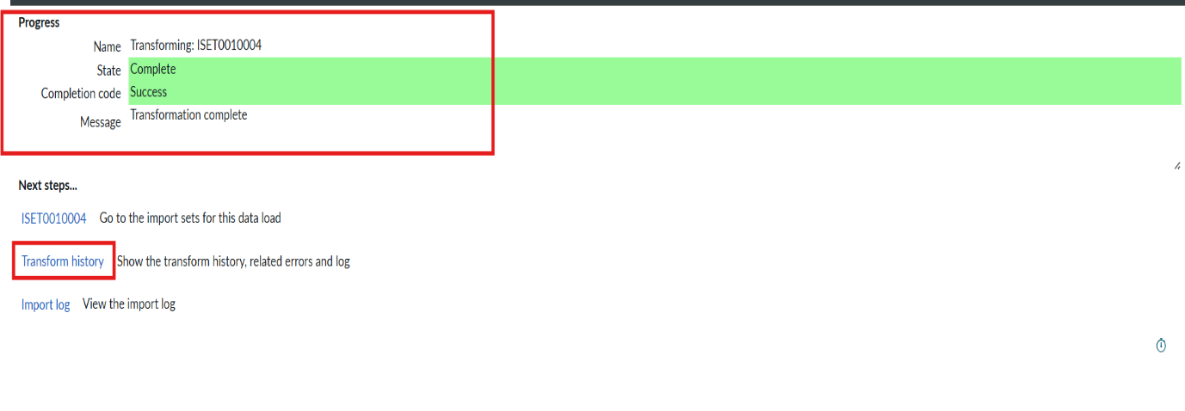
- Now the State is completed and Success.
- Now again click on the Transform history then it shows the newly added data and its status of Inserted and Skipped values out the given data.

Conclusion:
Transform Map provides a structured way to bring the external data in ServiceNow Platform with cleanliness and consistency. With above steps you can easily import and update the data in your instance. By mapping fields carefully and applying coalesce rules,we can efficiently and reliably import and update the bulk data within instance. Also, it safeguards the data integrity and uniqueness.

